**R Programming Language - Introduction**

R is a programming language and software environment that has become the first choice for statistical computing and data analysis. Developed in the early 1990s by Ross Ihaka and Robert Gentleman, R was built to simplify complex data manipulation and create clear, customizable visualizations. Over time, it has gained popularity among statisticians, data scientists and researchers because of its capabilities and the vast array of packages available.

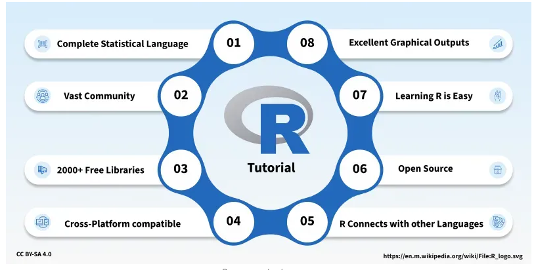

R programming Language

As data-driven decision-making has grown, R has established itself as an important tool in various industries, including finance and healthcare, due to its ability to handle large datasets and perform in-depth statistical analysis.

**Why Choose R Programming?**

R is a unique language that offers a wide range of features for data analysis, making it an essential tool for professionals in various fields. Here’s why R is preferred:

* **Free and Open-Source:** R is open to everyone, meaning users can modify, share and distribute their work freely.
* **Designed for Data:** R is built for data analysis, offering a comprehensive set of tools for statistical computing and graphics.
* **Large Package Repository:** The [Comprehensive R Archive Network (CRAN)](https://www.geeksforgeeks.org/r-language/what-is-cran-in-r-language/) offers thousands of add-on packages for specialized tasks.
* **Cross-Platform Compatibility:** R can work on Windows, Mac and Linux operating systems.
* **Great for Visualization:** With packages like [**ggplot2**](https://www.geeksforgeeks.org/r-language/data-visualization-with-r-and-ggplot2/), R makes it easy to create informative, interactive charts and plots.

**Key Features of R**

* **Cross-Platform Support:** R works on multiple operating systems, making it versatile for different environments.
* **Interactive Development:** R allows users to interactively experiment with data and see the results immediately.
* **Data Wrangling:** Tools like [**dplyr**](https://www.geeksforgeeks.org/r-language/dplyr-package-in-r-programming/) and **tidyr** help simplify data cleaning and transformation.
* **Statistical Modeling:** R has built-in support for various statistical models like regression, time-series analysis and clustering.
* **Reproducible Research:** With R Markdown, users can combine code, output and narrative in one document, ensuring their analysis is reproducible.

**Example Program in R**

To understand how R works, here’s a basic example where we calculate the mean and standard deviation of a dataset:

* We first create a vector data that contains numerical values.
* We use the **mean()** function to calculate the mean of the dataset.
* The **sd()** function calculates the standard deviation.

data <- c(5, 10, 15, 20, 25, 30, 35, 40, 45, 50)

mean_data <- mean(data)

print(paste("Mean: ", mean_data))

std_dev <- sd(data)

print(paste("Standard Deviation: ", std_dev))

**Output:**

[1] "Mean: 27.5"  
[1] "Standard Deviation: 15.1382517704875"

**Applications of R**

R is used in a variety of fields, including:

* **Data Science and Machine Learning**: R is widely used for data analysis, statistical modeling and machine learning tasks.
* **Finance:** Financial analysts use R for quantitative modeling and risk analysis.
* **Healthcare:** In clinical research, R helps analyze medical data and test hypotheses.
* **Academia:** Researchers and statisticians use R for data analysis and publishing reproducible research.

**Advantages of R Programming**

* **Comprehensive Statistical Tools:** R includes many statistical functions and models, making it the ideal choice for data analysis.
* **Customizable Visualizations:** R’s visualization tools allows for customizations for a simple bar chart or a detailed heatmap.
* **Extensive Community Support**: R has a large user base and there are countless resources, forums and tutorials available.
* **Highly Extendable:** The availability of over 15,000 R packages means we can extend R's functionality to suit any project or need.

**Disadvantages of R Programming**

* **Memory Intensive:** R can be slow with very large datasets, consuming a lot of memory.
* **Limited Support for Error Handling:** Unlike some other programming languages, R has less robust error handling features.
* **Steeper Learning Curve:** Beginners might face challenges with some of R’s complex features and syntax.
* **Performance:** R’s performance can lag behind languages like Python or C++ when it comes to speed, especially for large-scale operations.

In this article, we’ve seen how R is an tool for data analysis, statistical computing and visualization. Its open-source nature, comprehensive feature set and active community make it an excellent choice for both beginners and seasoned professionals.